Team: Cult of Cactaur (Brian Smith, Chris Haire, Roger Norris, Jason Shelton)
Game: XenoHammer
Preliminary Game Proposal

Genre – 2D Space shooter with RPG Flare
Technical Focus - Single player, 1 level (divided into 3 sub levels)

Back-story –

2066 – December 7 - First alien contact is made with Earth by the Crystalline race.
“Earth: We, the Sylgan, of the Universal Protectorate, have been watching you for some time, Earthlings, and did not want to interfere in your world. However, the great need of the universe beckons our call for your assistance. A super race of aliens, known as the Drothcans, is ritualistically cleansing the universe of all other life forms. They have already destroyed 14 other races, and the remaining 28 are all technologically lower than us. Unfortunately, as the Drothcans destroy other races they acquire their resources and their technology. It seems that the Drothcans forces are reaching critical mass, wherein all resistance will be useless. We are here to warn you, the Drothcans are rapidly approaching Earth. The loss of Earth and all its valuable resources would ensure the Drothcan cleansing could not be stopped. Originally, we had calculated that it would take the Drothcans 12 of your Earth years to reach your planet. Recently, this all changed when the Drothcans acquired experimental technology scavenged from an alien race that now allows them to travel twice as fast. The Drothcan fleet will arrive at Earth in a little under 6 years. We must make our last stand here; it is unavoidable. Earth will be the battleground for the intergalactic conflict that will determine the future of the Universe. En route to Earth is a large fleet, which is all that remains of the once massive Universal Protectorate. However, it will take approximately 6 years to make the journey. This means there will be a small window of time where we will be defenseless at Earth. It is our job to leverage all known technological innovations and collaborate with your scientists to build a defense network to hold off the Drothca until the Universal Protectorate fleet arrives. Time is of the utmost importance; let us know your decision”

2067 – January 1 - Project “XenoHammer” begins – A hybrid space fighter program to create the most elite war machine in the universe
2072 – Aug 2 – Defense network “Nova Flux” goes online
2072 – Aug 14 – Operation “Eternal Silence” begins – a secret mission using the XenoHammer warship to knock out the nerve center of Drothca communications to paralyze the Drothcan Fleet until the Universal Protectorate arrives.

Game Description –
The player pilots a ship attempting to infiltrate alien defenses and knock out the main alien communication center. Unlike many 2D overhead shooters, the player only has one ship. This ship represents the “character” that will be upgraded and modified throughout the course of the game so we decided it doesn’t make sense to have more than one. Since the player is limited to only one ship, it is equipped with shields and armor so the player can take damage without dying. The ship is also equipped with a set of 5 weapons. One main nose cannon, two wing turrets, that can be upgraded to allow for dynamic rotation, and two wing missile launchers, that can be upgraded to allow for homing). (Please see Appendix A for specific information on each weapon type). When the player destroys aliens, there is a chance that a power-up will be dropped. The power-up is not traditional, and comes in the form of a power cell or resource units. The player will collect these power-ups for purchasing upgrades to their ship at the end of each level.

At the end of each mini level, the player will return to his base ship that accompanies him on his journey to the final boss. The player will be able to trade in the collected power-ups to add to the energy capacity of his ship. The ship is equipped with 6 power plants. Each power plant powers a specific device and has two main power cells that can each be charged up to 5 units (see power plant discussion below). For example, the ships main power plant is responsible for distributing power between the shield recharge rate and the engine power, which controls the speed of the ship. A player would trade in a certain amount of power-ups, the amount unknown at this time since it will be tweaked while play testing, to add to the overall level of power for that power plant. Each power plant can hold up to 10 energy units. Our “energy variant settings” option in the game, allows the player to dynamically switch how the power is routed through the power plants based on settings that the player predefines. Each variant is assigned to a hot key. The GUI for the defining and adding of the ship power has not yet been finalized, so that will be presented once completed. During the game, all of the ship information will be presented to the user on the right side of the screen via the console (see in game sketch for specifics). This lets the player fine tune his ship for whatever situation presents itself. An example would be the nose cannon; lets assume that we currently have 5 power units distributed, 2 units in power cell #1, and 3 units in power cell #2. In all weapons, power cell #1 corresponds to the rate that the weapon fires and power cell #2 corresponds to the power, or damage, that the weapon projectile will do. (In ship power systems, power cell #1 corresponds to shield strength and power cell #2 corresponds to engine power.)
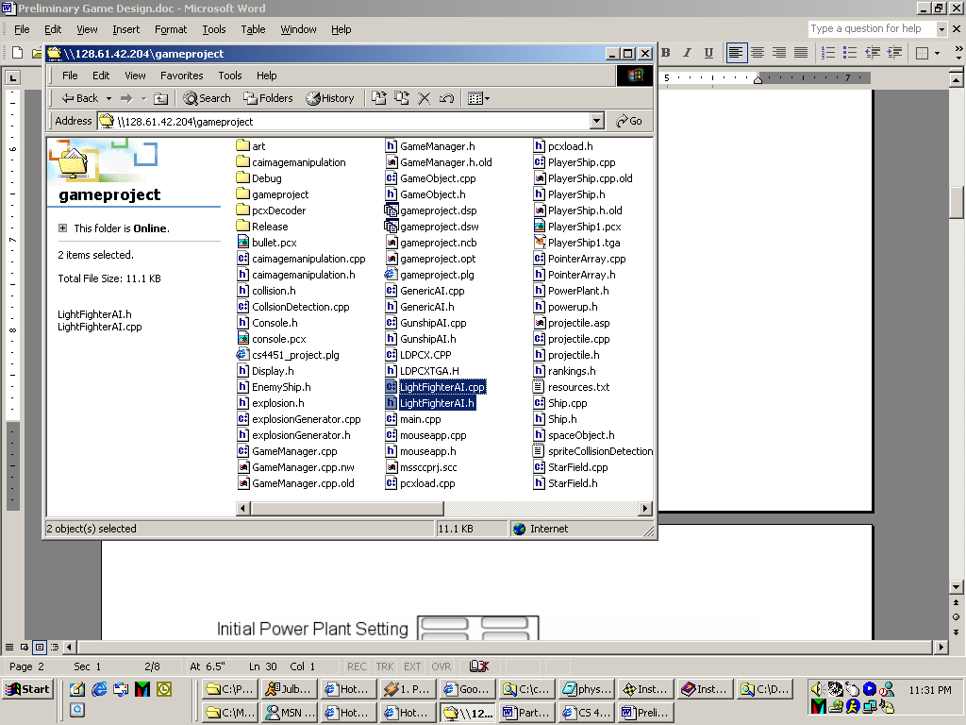
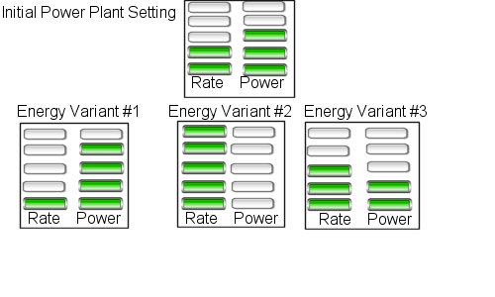
Energy Variant #1 would be used by the player when they wished to shoot at a slower rate but with higher damage per shot. This would most likely be used in a situation where a larger, slower enemy is attacking – such as a capital ship or a boss.

Energy Variant #2 would be used when the player needs a high rate of fire with lower damage per shot. This would probably be used against an oncoming wave of light fighters.

Energy Variant #3 would be used as an all-purpose setting with a moderate rate of fire and moderate amount of damage per shot, somewhere between energy variant #1 and #2, which probably would be useful against moderate strength enemies.

A detailed discussion of the characteristics of each of the weapons and how each power unit affects the damage/firing rate can be found in Appendix A. All power plants work in the same fashion for both enemies and the player ship. Weapons that the enemies will shoot at the player will also be based off of the same model discussed above. The game engine design focuses on objects and components, thus allowing all ships to be built off the same base classes and add weapons and ship power systems, or components. This allows us to quickly build new enemies with different strengths based on the values in their power plants.

As the player progresses through the levels of the game the player will, of course, be attacked by many different kinds of enemy ships. These enemy ships will appear in predefined waves that will be the same from game to game. Enemies will appear in predefined formations, flying onto the screen, and then beginning to move and attack the player according to their AI.
The player will encounter a variety of foes, which can be divided into two main groups: capital ships and fighters. Capital ships will have very strong shields and multiple weapon systems to shoot at the player but will not move around much. Meanwhile, fighters will take fewer hits to destroy but will move around and appear in much larger numbers.
There will be three main types of fighters that the player will encounter: light fighters, bombers, and gunships. The three types of enemy craft will have varying shield strengths and weapon systems, with the light fighter taking very few hits to destroy and the bomber taking the most. Each of these enemy types will have at least one set of behavior specific to that ship type. Light fighters may charge the player, take a shot at the player, and then peel out of formation to turn around for another run. Gunships may take a different approach, strafing back and forth in front of the player and firing their weapons in short bursts. Meanwhile bombers may just do fly-bys and attack with a rotating turret.
Capital ships will move very slowly down the screen while firing at the player using a variety of weapon systems. Capital ships will have extremely strong shields but may have a higher probability of dropping a power-up that the player can collect.
Weapons used by the enemies will be similar to the player's own weapons. Each of the three fighter craft will primarily use one of the three weapon systems that the player has: blasters, torpedoes, and missiles. The bomber may have both torpedoes and a rotating blaster turret. Capital ships will use a combination of these weapons plus a minelayer, which can lay stationary mines that stay on the screen for a length of time or until shot.
As the game progresses, the enemy ships will become stronger by receiving less damage per enemy shot that hits the ship and by upgrading weapon systems that either fire faster or hit harder. Enemy ships may begin to use harder, or at least different, AI’s on later levels, and enemy types will be grouped together to make the player's life more difficult. On the early levels the enemy ships will tend to appear only one type or wave at a time, making it easy for the player to dodge their fire and counter that particular AI. Later levels will present the player with multiple enemy types attacking together, and the different AI’s and targeting algorithms will make the player's job more difficult.

Game Design Layers

Functional Minimum – (Sept 25th) Skeleton engine functionality, 1 enemy with ability to shoot bullets (non intelligent), player ship with ability to shoot bullets, simple bounding box collision detection, enemy kill counter

Low Target – (Oct 15th) Engine core completed, pixel level Collision detection, enemy shoots pseudo intelligently, Startup screen, 1 full level, real-time statistics on ship updated in console, simple sound effects

Desirable Target –(Nov 10th) 2 levels, collection of resources, scoring system (kills and pilot ranking), in game variant energy settings, real enemy AI (with ability to turn ships dynamically), 2 types of enemies, all 3 player weapons have 5 different firing modes, finalized sound effects, in between level ship setup GUI, player/ship save

High Target – (Dec 7th) 3 levels, w/ boss, 5 enemy ships with varying difficulty, Upgrade weapons (rotating turrets and homing missiles), music, explosion generator

Extras - More levels, more enemies, tile based backgrounds, cut scenes, music synced to action, arcade mode vs. story mode, networking or 2 player support, addictive game play ;-)

Basic Breakdown of above work:

Brian: Engine

Chris: Engine Add-ons, level design, saving/loading, Sound & music

Jason: Startup GUI, Ship settings GUI, In-game GUI, all artwork for GUI’s

Roger: Artwork and animations, AI, level design

Tools:
Game Engine: To handle DirectX stuff we’re using a higher-level library called ClanLib. ClanLib supports most of DirectX (except 3d), built in support for GUI’s and making loading artwork and handling game management (sounds, data and frame callbacks, etc.) easier than if we used DirectX.

Art: We used POVRay and PhotoShop to do all game art.

Assessment:
The main strength of our game will lie in the RPG like quality we are adding to the overhead shooter genre. We will allow the user to collect power-ups, in the form of resource and energy units, during a level that they can use for research and/or developing upon their existing weapons. The coolest part of our game is the ability to give the player a sense of ownership in the game by the development of the ship they use. In many of today's overhead shooters you have three or four lives that you play the game with and you gain and lose weapons rapidly. We are allowing the user to have one ship to modify as they see fit and take that one ship throughout the game. The people who are most likely to play our game are future games class students because they will be the group of people most exposed to our game. We also plan to attract people who have played past overhead shooters and perhaps some RPG fans. In our game the user pilots a fighter with enormous power. They kill aliens and lots of them, but at the same time they collect resources to upgrade their ship and also gain rankings based on number of kills.

The virtual world we are simulating is similar to how other 2D overhead space shooter games present their virtual world. We are simulating space travel and fighting, but the world is based on our fictional interpretation of how space travel and fighting would take place around the year 2070. Our games success should be based on how much people enjoy playing our game, particularly people who are familiar with other games in the genre. Additionally, our team’s success should be based on how well we implement our design, including how successful we are in simulating the virtual world.
Appendix A: Vehicle and Weapon power plant information

Damage Scale:
These are the base damage values – if the power plant power settings are at 0

Torpedo – 10 (size of shot increases as MUX level increases)
Blaster – 6 (size of shot increases as MUX level increases)
Turret – 4 (size of shot increases as MUX level increases)

MUX scale: Initial power rating is at 2 blocks for each power plant
To determine the effect of the power unit, take the base value of the device and multiply it with the corresponding MUX value.

Total of 10 blocks per power plant
Level 0 – 1x
Level 1 – 1.5x
Level 2 – 2x
Level 3 – 2.5x
Level 4 – 3x
Level 5 – 5x

Power plant data
6 power plants x 10 total units = 60 total units
Initial amount of units given = 12 total units
40 units that the player can attempt to buy
We will only allow 28 extra units to be purchased.
This would allow for all systems in a ship to be at level 4. This will force the player to make a choice as to what systems they really want to be at level 5.

Each weapon has own power plant
Blaster (nose)
(shared power plant)
Shot rate 5 blocks
Shot power 5 blocks

Standard turret (wings)
(shared power plant)
-Shot rate 5 blocks
-shot power 5 blocks
-Rotating turret (2pi possible directions)

Torpedo launchers
(shared power plant)
- shot rate 5 blocks
- shot power 5 blocks
- homing

ship upgrades

(shared power plant)
shields - 5 blocks
engine (maneuverability) – 5 blocks

armor upgrades – light/medium/heavy

energy burst – one time use (ship can hold 2)

Possible add-on power up: This “energy burst” super charges your ship, topping off the power in every one of your power plants and making you an unstoppable killing machine. However, the effect is very limited in time (will be set based on play testing).

